|  |
| --- |
|  |

|  |
| --- |
|  |
| VA Solid Start Program Agent User Guide V1.4 |
|  |
| Outbound Call Center |
|  |

# Table of Contents

[Table of Contents 1](#_Toc23522442)

VA Solid Start [Introduction 2](#_Toc23522443)

[Lesson One: Logging In and Overview 3](#_Toc23522444)

[Lesson Two: VASS Interactions 6](#_Toc23522445)

[Lesson Three: Making Outbound Calls 9](#_Toc23522446)

[Lesson Four: Emails 14](#_Toc23522447)

[Lesson Five: Resolving an Interaction 18](#_Toc23522448)

[Lesson Six: Inbound Calls 19](#_Toc23522449)

[Practice Activity 20](#_Toc23522450)

[Module Summary/Review 21](#_Toc23522451)

# VA Solid Start Introduction

Introduction

The purpose of this documentation is to guide the User supporting the VA Solid Start Program (VASS). The VA Solid Start program was established to meet requirements outlined in Executive Order 13822, *Supporting Our Veterans During Their Transition From Uniformed Service to Civilian Life*, for consistent and caring contact as a means to improve transition outcomes and prevent Veteran suicides. This Executive Order focused heavily on mental health issues and is sometimes referred to as the VA Solid Start Program (VASS).

This documentation will teach agents to leverage the outbound call center Application built on Dynamics 365 online. The Application will enable call center agents and administrators to make outbound calls to recently transitioned Servicemembers, regardless of the character of discharge, at key intervals (0-90 days, 91-180 days, and 181-365 days) during the first year after separation from military service.

Throughout the remainder of the course materials, the transitioning Servicemembers will be referred to as “Veterans”, even though some individuals do not meet the qualifications to be identified as a Veteran. Per 38 CFR § 3.1(d), a veteran is “a person who served in the active military, naval, or air service and who was discharged or released under conditions other than dishonorable.” The VA Solid Start program will be contacting every recently transitioned Servicemember, regardless of his/her character of discharge.

There are six lessons in this Module:

1. Lesson One: Logging in and Overview:

Illustrates the log-in process.

1. Lesson Two: VASS Interactions

Describes the Agent Dashboard and the VASS Interaction screen and how to navigate through the form.

1. Lesson Three: Making Outbound Calls

Explains how to make outbound calls and log outbound attempts in the system.

1. Lesson Four: Emails

Describes email communications with the separating Veteran.

1. Lesson Five: Resolving an Interaction

Walks through the steps to close an interaction when it is completed.

1. Lesson Six: Inbound Calls

Illustrates different methods to perform Veteran search (e.g., by SSN, first name, last name etc.)

Notes

The VASS system is only accessible through the Browser. Please copy the following URLs.

**Production environment:**

<https://dvagov-udo-prod4.crm9.dynamics.com/apps/vass>

**Pre-production environment:**

[https://dvagov-udo-preprod2.crm9.dynamics.com/apps/vass](https://dvagov-udo-preprod2.crm9.dynamics.com/apps/vass" \o "https://dvagov-udo-preprod2.crm9.dynamics.com/apps/vass" \t "_blank)

# Lesson One: Logging In and Overview

This lesson will explain how to access the VASS application from the desktop and log into the Application. Be sure that your PIV is inserted before navigating to the Agent Dashboard.

You may see a shortcut icon on your desktop for the VASS dashboard. If you do not see this icon navigate to <https://dvagov-udo-prod4.crm9.dynamics.com/apps/vass>. Click the shortcut icon/URL to launch the application. Once your default browser opens, you will get a Login Prompt, illustrated below. Click your VA login to proceed.

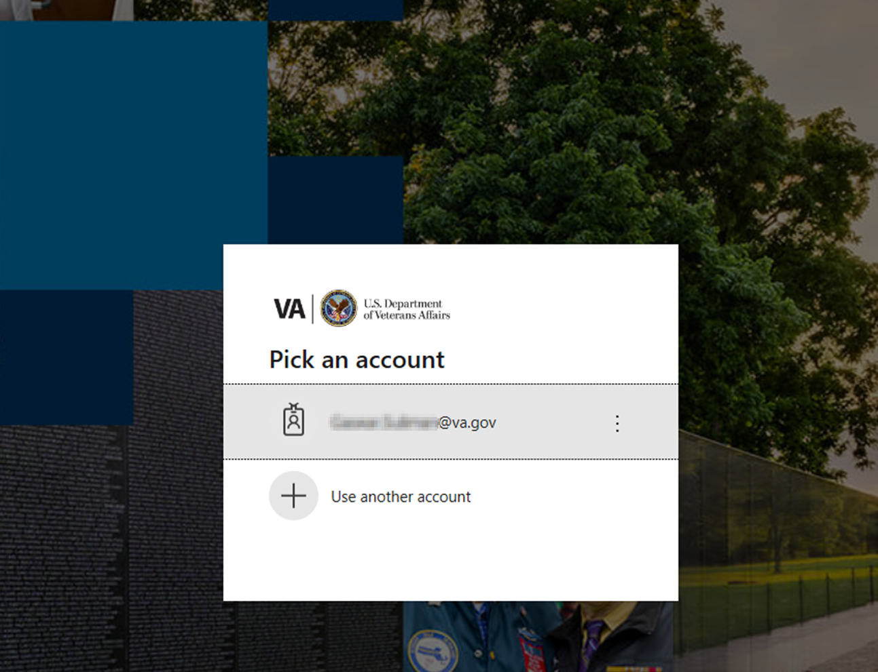

Upon successful login, you will be directed to your Landing Page.

The top Navigation bar (screenshot below, slide 3) will always be visible on all screens and functions of the application.

The Navigation bar:

1. Indicates the current page and provides breadcrumbs illustrating your navigation steps
2. When accessing non-Prod VASS Environments, the keyword “**SANDBOX**” will appear. In Production, you will not see the keyword “**SANDBOX**”
3. On the right-hand side, additional options are available:
   1. Global Search –This feature is disabled for VASS.
   2. Quick Create – Quickly create a new record or activity from anywhere in Dynamics 365
   3. Advanced Find – Create advanced search queries of data you have access to
   4. Personal Options – Settings and personal preferences
   5. Help – Search for help and training on Dynamics 365



On the left-hand side, the Sitemap Navigation Pane will always be presented to you:

1. **Home**: Navigate back to the Landing Page
2. **Recent**: List the recent items you've opened in the Application (e.g. Interactions, or Veterans record)
3. **Pinned**: the records or Views the User has pinned
4. **Agent Workplace**:
   1. **Dashboards**: In VASS, there are three System Dashboards: National Dashboard, Call Center Manager Dashboard, and Agent Dashboard. You will only be able to access the dashboards for which you have been granted access.
   2. **Veterans**: The navigational link to perform a Veteran search discussed in Lesson Six (6)

# Lesson Two: VASS Interactions

The VASS Agent Dashboard is the landing page for the application.

*VASS My Current Interactions*

Each row under the *VASS My Current Interactions* tab is called an interaction row. You will double click an interaction row to navigate to the *VASS Interaction Form*.

There are 4 tabs on the *VASS Interaction Form*:

* Details
* Health Enrollment/Eligibility
* All VASS Call Attempts
* Emails
* In this lesson, we will talk about the *Details* tab, *Health Enrollment/Eligibility* tab, and *All VASS Call Attempts* tab. Emails will be covered in Lesson Five (5).

The **VASS Agent Dashboard** will only display the interactions that are assigned to you and have already been started. Your displayed interactions will have an **interval start** of today or in the past. The days remaining for each interaction will display under the **Days Remaining** column. You will see:

* a green circle when the interaction has more than 30 days remaining,
* a yellow circle when interaction has 30 days or fewer remaining, and,
* a red circle when the interaction is past due.

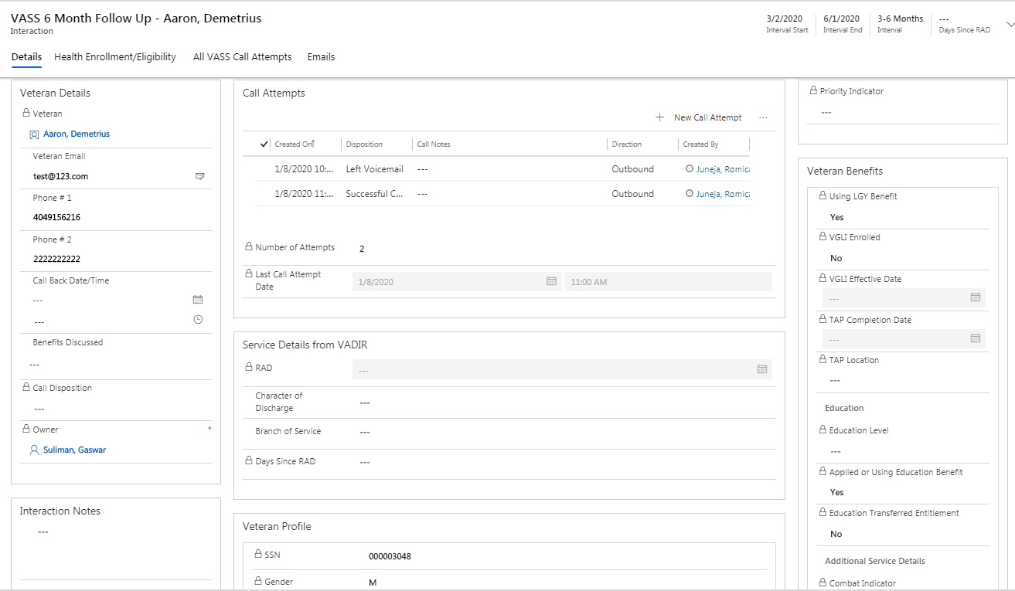

The **Details tab** has 6 sections that display important information related to the Veteran. Those sections are explained below.

**Veteran Details section**

The demographic information for the Veteran is displayed on the “Veteran Details” section. Most of the fields in this section are editable.

* The Veteran field is a hyperlink to the Veteran’s record.
* The **Call Back Data/Time** is enabled to specify a future date/time to call the Veteran back if requested.
* The **Benefits Discussed** field is a multi-select dropdown to choose one or more benefits discussed during the call.
* The **Call Disposition** is a read-only field that gets automatically filled out when the interaction is closed.

**Call Attempts section**

The **Call Attempts section** logs the total number of call attempts and the details of each call. Date/time, disposition, and call notes are logged for each one. Specific steps on how to log each call attempt is provided in Lesson Four (4).

**Interaction Notes section**

You will use **the Interaction Notes section** to create notes. This is a multi-line text field.

**Veteran Benefits section**

The **Veteran Benefits section** will provide **read-only** informationregarding the benefits, education, and service details for the Veteran.

**Service Details from VADIR section**

This section displays the read-only fields RAD and Days Since RAD and displays the editable fields – Character of Discharge and Branch of Service.

Days Since RAD is an automatically calculated field that tells the total days lapsed from the date that Veteran is discharged and provides a running ticker of the number of days lapsed from the date of his/her discharge (RAD).

**Veteran Profile section**

**The Veteran Profile section** displays the Veteran’s basic information in **read-only format**. This section displays the Veteran’s Social Security Number, date of birth, gender, etc.

**Health Enrollment/Eligibility**

**Health Enrollment/Eligibility** tab displays related health eligibility & enrollment for the Veteran. The displayed information is in **read-only format.**

**All VASS Call Attempts** tab shows you the complete history of call attempts made on this Veteran.

# Lesson Three: Making Outbound Calls

This lesson explains how to make an outbound call to the identified Veteran and how to log each call attempt for reference. VA Solid Start will attempt to contact the Veteran up to 7 times for each interaction interval.

1. You must have CISCO IP Communicator Open.

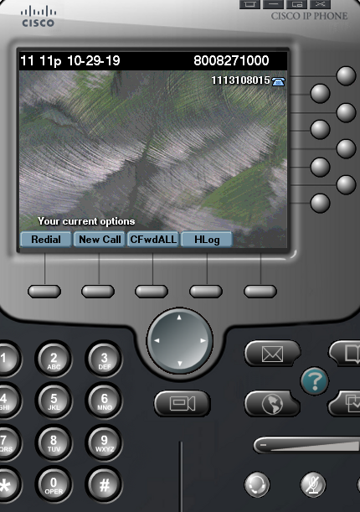

1. Log into CISCO Finesse in the Not-Ready status.

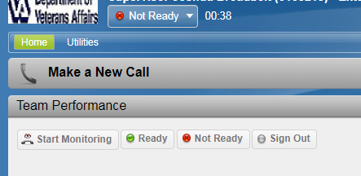

1. Navigate to the VASS application. All calls will be made through the VASS dashboard. You must use the ***Call*** button in the top left.

1. You have the option to call either the listed mobile or home phone number under the Veteran Details. Select the desired phone number.

1. The application will then notify you that it is making an outbound call.

1. The phone call will register in CISCO Finesse and CISCO IP Communicator. The CISCO functionality for outbound calls is identical to inbound calls.

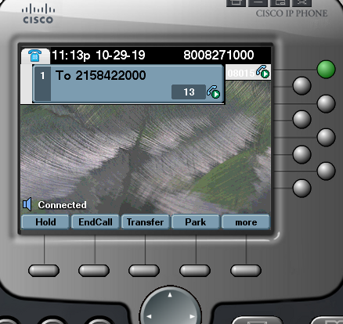

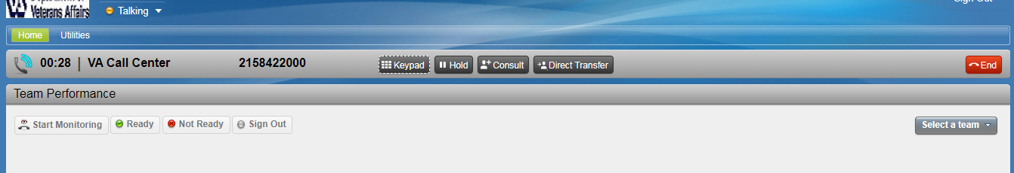

1. You must use the VASS dashboard to make outbound calls. Do not make outbound phone calls directly in CISCO IP Communicator.

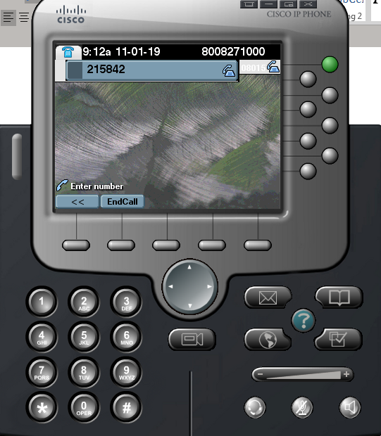

1. While the outbound call is dialing, click on the ellipses, “****”, button under the **Call Attempts** section on the **Details Tab. You** will have the option to create a **New Call Attempt.** Select this optiontorecord how the phone call was answered.

**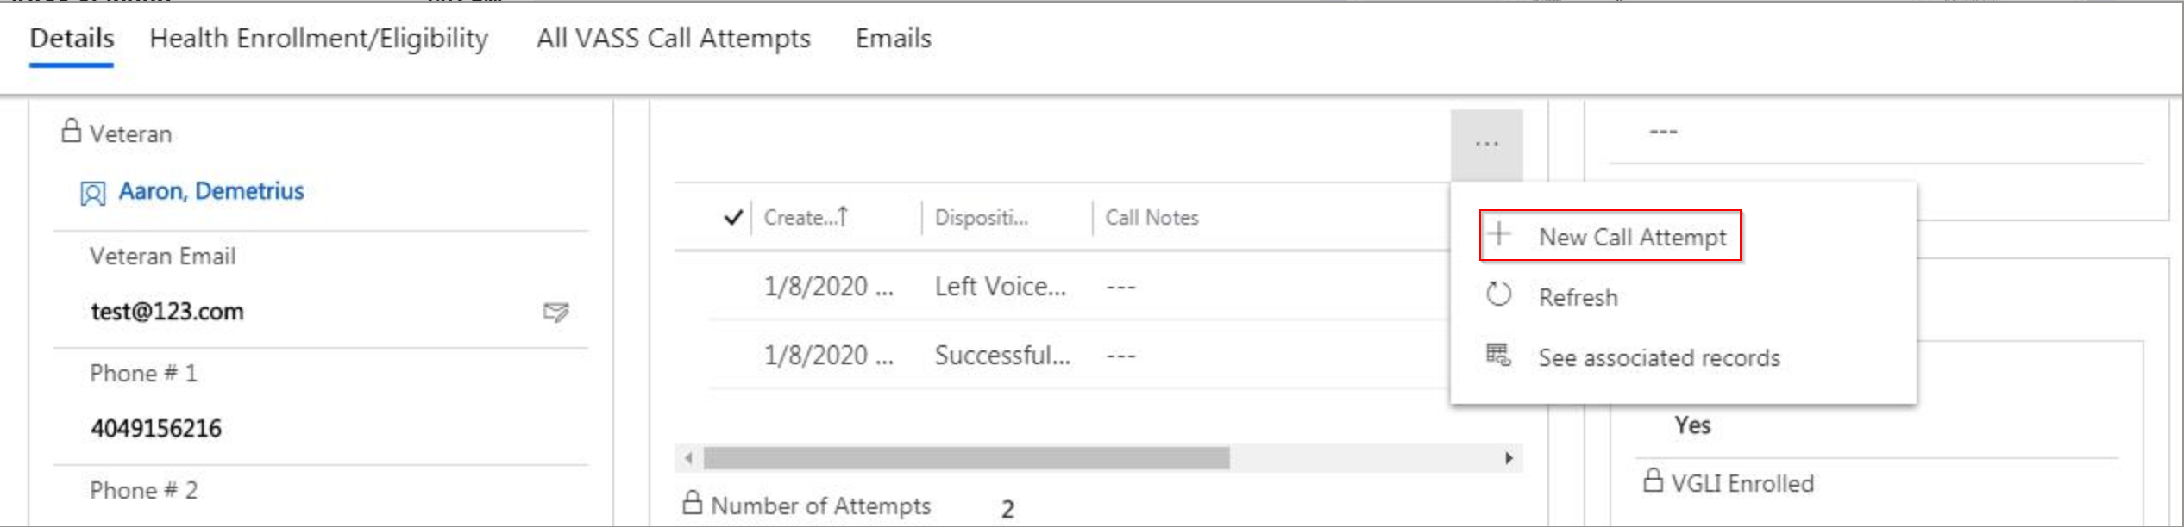**

1. The **New Call Attempt** dropdown shows the **Disposition** field. There are 5 options to select based on how the call attempt was answered. Select the option that most accurately describes what happened:

* **Successful Contact:**

You reached the Veteran and offered the VA Solid Start information.

* **Left Voicemail**

You left a voicemail.

* **Do Not Contact Request**

The Veteran indicated that he/she doesn’t want to be contacted.

* **Unable to Contact/Bad Phone Number**

Use this code if:

* A third party answers the call
* The number is to another party (wrong number)
* The provided number is out of service/ unreachable.
* **Call Back Request**

Document if the Veteran requested a call at a different time.

1. After filling out the three fields and click **save and close** button to close the call attempt window.

# Lesson Four: Emails

In this lesson, we will cover both the email draft template and automatically sent emails sent to Veterans under the VA Solid Start Program . There is one draft email, **VA Solid Start Recap Email**, that requires your review and action to send. Two emails, the **First Failed Contact Email** and **Final (7th) Failed Contact Email**, are automatically generated and sent by the system. All email drafts can be viewed under the *Emails Tab.*

*Action required email*

* **VA Solid Start Recap email (draft email):** This draft email is created when the **New Outbound Call Attempt Disposition** is loggedas *successful*. Before logging a successful Attempt, verify the Veteran’s email and update it in the Veteran’s Details section, if necessary. This draft email can be viewed by navigating to the **Emails Tab.**

****

You are required to review the draft for completeness. To edit the Recap email, you will navigate to the **Emails** Tab and open the **VA Solid Start Recap** email by double-clicking the row. This will open the email screen. Follow these steps to edit the email:

1. Click the Insert Template Ribbon buttonA screenshot of a social media post

   Description automatically generated
2. The **Insert Template** popup will appear

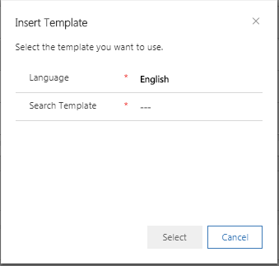

1. Click on the  icon. You will be presented with the Veteran-specific email templates that are available. Select the applicable template and click “Select”.

1. The selected Email Template will populate in the Email Body. You can further personalize and edit the email body before sending. While editing is possible directly in the tool, the editing functions are limited.

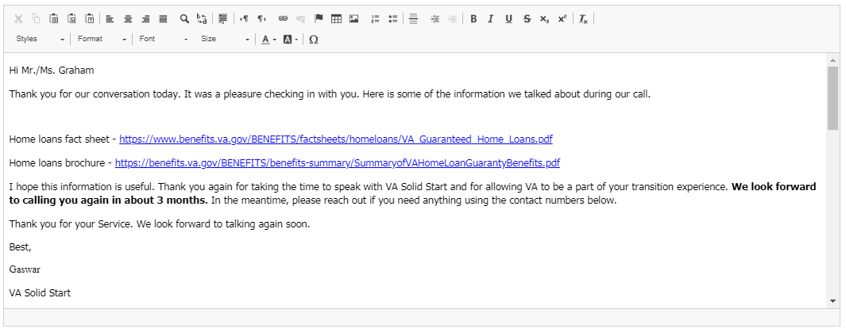

1. Click the **Send** button in the top left corner of the Email window to Send the Email to the Veteran.

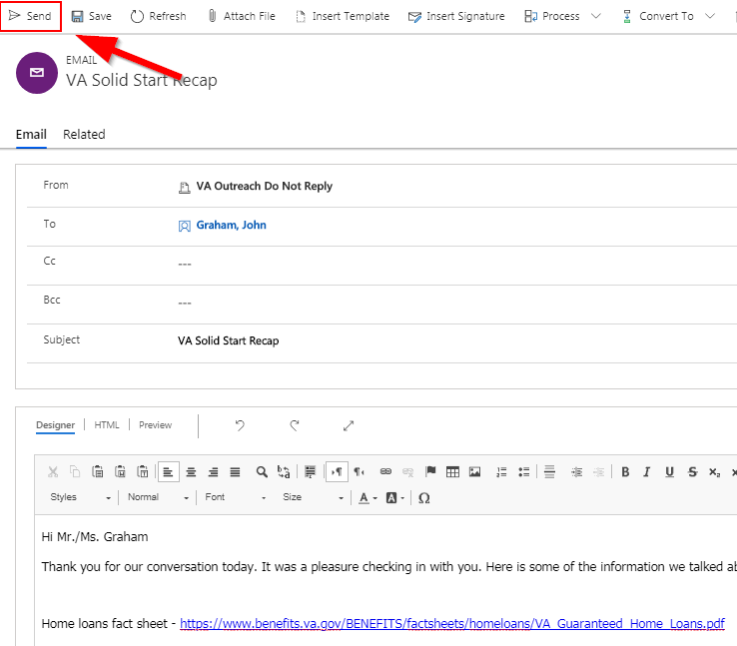

Automatic Emails:

There are two automatically sent emails: **First Failed Contact** **email** and **Final (7th) Failed Contact Email**.

1. **First Failed Contact Email:** This email is created when the **New Outbound Call Attempt Disposition** is loggedas **Left Voicemail** or **Unable to Contact/Bad Phone Number**. When the first failed Outbound Call Attempt is registered for a Veteran, the System-generated email will automatically send to the Veteran. No action is required by you to send this email. You cannot edit this email body since it is a system-managed email. You can, however, review the contents of the message by navigating to the **Emails** Tab and double-clicking on the email as shown below.

In non-Production (test) environments, the email will remain in a “Pending Send” status. Test environments have email capability turned off to prevent sending emails during validation and testing.

1. **Final (7th) Failed Contact Email:** This email is created when the seventh failed Outbound Call Attempt is made. Once the call is closed as **Failed to Make Contact**, a System-generated email will be automatically sent to the Veteran. This email is similar to the **First Failed Contact Email** and requiresno action from you. You cannot edit this Email body since it is a system managed email. You can, however, review the contents of the message by navigating to the **Emails** Tab and double-clicking on the email:

****

# Lesson Five: Resolving an Interaction

In this lesson, we will cover how to close an interaction. An interaction in your VASS Dashboard can be closed for one of the following reasons:

1. Successful contact was made with the Veteran, or
2. The Veteran was not contacted after seven call attempts for the interval or cohort, or
3. The interaction contains no contact information (i.e. no Mobile or Home) making the Veteran unreachable.

The **Resolve Interaction** button is located at the top of the VASS Interaction form. Select this to display two options:

* **Successful Contact Made** and
* **Failed to Make Contact**.

Selecting either of these options will close the interaction and automatically update the **Call Disposition field** on **Details tab** under the **Veteran Details** section.

Please Note:

* Closed Interactions will be removed from your **My Current VASS Interaction** view on the dashboard.
* The **Resolve Interaction** button is only displayed on open interactions. The **Resolve Interaction** button is no longer available after the interaction has already been resolved.

# Lesson Six: Inbound Calls

You may receive an inbound phone call related to VA Solid Start, and you will need to access the Veteran’s record to proceed. You may search for a Veteran using the Master Veteran Inquiry (MVI).

The **Veteran’s** navigational link is listed as the second option under Agent Workplace. Clicking on it will take you to VASS Veterans view. The search box is on the right (highlighted below in the screenshot). The search is similar to the inbound call center search functions. You will only be able to locate records at or below your assigned sensitivity level (e.g. Agents with level 7 can only search for Veterans that are level 7 or lower).

To perform a Social Security Number (SSN) search:

1. Enter the SSN in the **Search for records** field and either press the Enter key or click the  icon
2. The system will present all records that list that SSN. There may be multiple records be due to bad data, duplicates, etc. Use the current guidance on duplicate records to address data mismatches and multiple files for the same Veteran.

**Take Ownership**

The **Take Ownership** button is used to take ownership of the interaction that is assigned to another agent when a Veteran calls in. The agent who receives the call and closes the interaction for Veteran will have the ability to have the current and remaining open interactions for future intervals assigned to him as well, so that the agent can continue the relationship with the Veteran.

This button is located at the top of the VASS Interaction form.

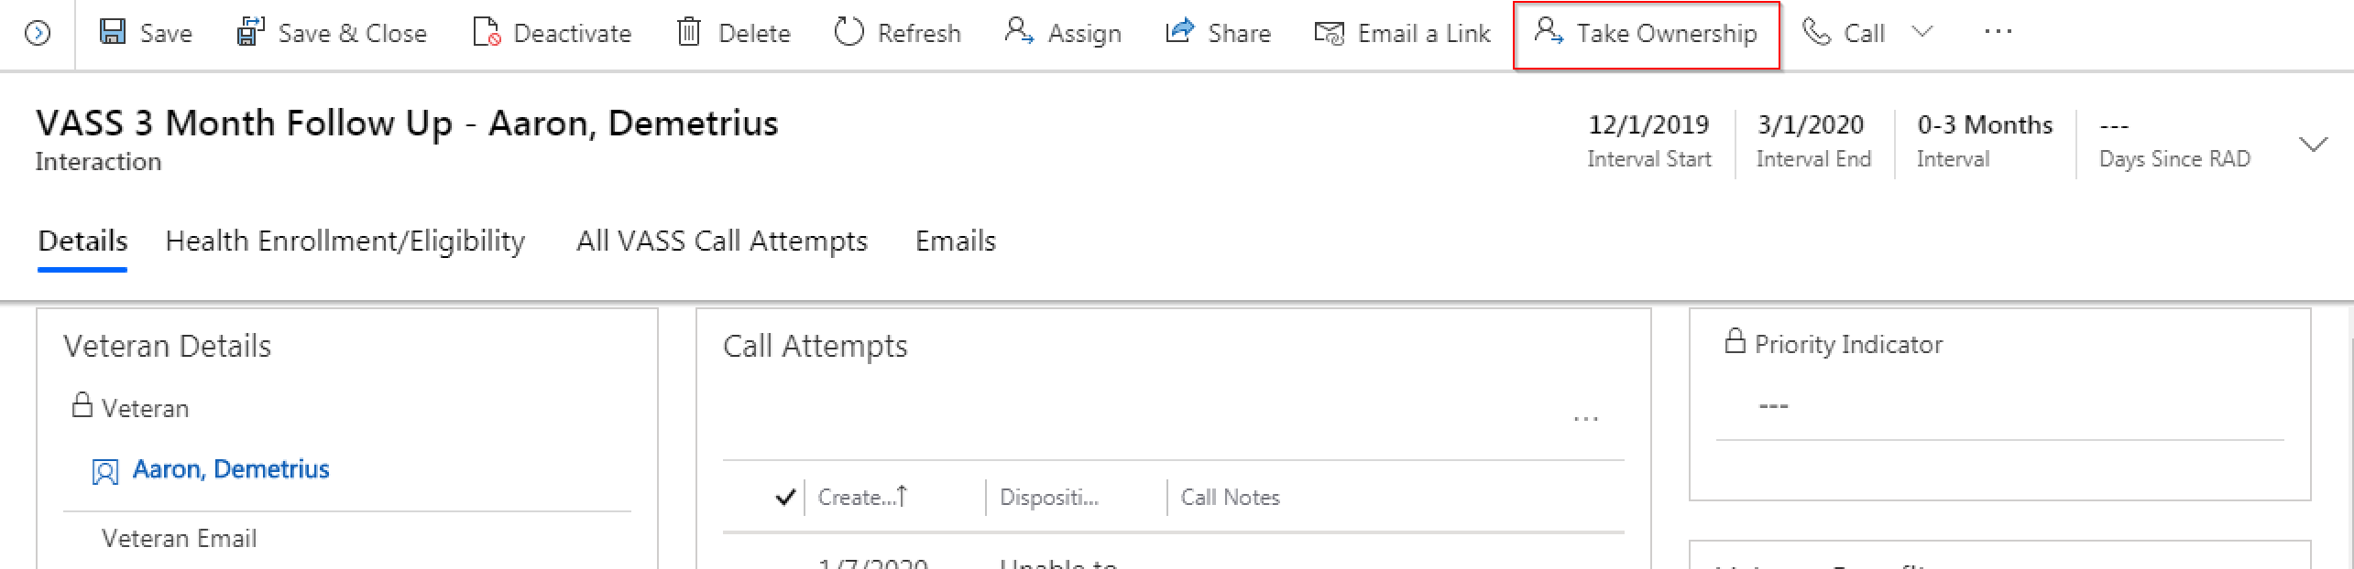

When an agent clicks the Take Ownership button, a confirmation dialog box is displayed to make sure that the agent wants to transfer the ownership of current and all future VASS interactions for that Veteran.

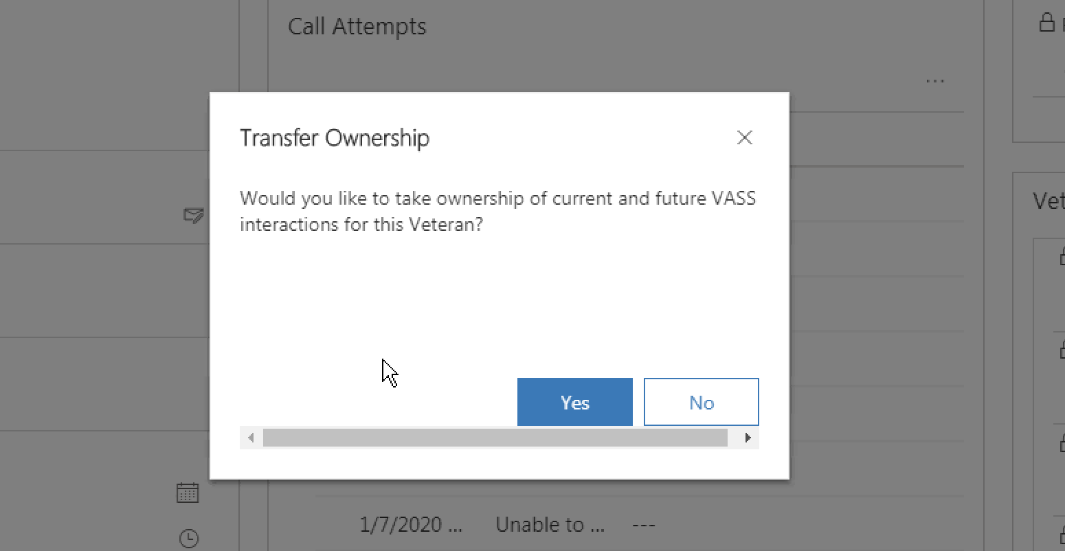

After the agent confirms and clicks *Yes*, that agent is assigned as the owner of the current and future interactions for that Veteran. The *Owner* field in the *Veteran Details* section of the interaction form gets updated to the agent who transferred the ownership.

# Practice Activity

Let’s do a few practice exercises to get you more comfortable with the VA Solid Start process.

1. Log into D365 system (Lesson 1)
2. Go on Interaction VASS form (Lesson 2)
3. Make an outbound call and log outbound call attempt details (Lesson 3)
4. Check Email to be sent based on call attempt disposition type. (Lesson 4)
5. Resolve an interaction (Lesson 5)
6. Locate a Veteran by SSN and Take Ownership of an interaction (Lesson 6)

**Role Play and Examples:**

You placed an outbound call and reached a business line switchboard for Testing’R US. The number asks for you to enter an extension, but no names are provided. You have tried selecting “0” and using the # and \* symbols. You are unable to reach a person. What is the disposition code of this call? Does the Veteran stay in the Solid Start Program for the next call?

You’ve reached Test Veteran GI Joe and he tells you this is a bad time to talk. He’s asked for a return his call after 8:00 PM on Thursdays. What action would you take and how to your record his request in the system?

You realize that you forgot to close a successful call with Julie Testing Gems about an hour ago. What steps would you take? If you close this interaction, what will happen to Ms. Gems’ record on your dashboard? Where are your closed interactions located in the VASS CRM?

# Module Summary/Review

Congratulations! You have reached the end of this module.

By now, you have learned the VASS process to document your interactions with Veterans and are ready to help Veterans during VA Solid Start!

In summary, most of your activities occur on the VASS Interaction Form. The **Details Tab** helps you to identity the Veteran to call. The **Health Enrollment/Eligibility** tab displays health eligibility & enrollment information for your caller. The VASS Call Attempts tab shows you all call attempts that have been made for each interaction.

The Emails tab is your notification tab. All the system auto generated emails regarding call attempts are logged here for your reference.